**COINCENT**

**MICROSOFT MACHINE LEARNING COURSE**

**SELF DRIVING CAR USING MACHINE LEARNING**

**ABHISHEK PATRO**

ABSTRACT:-

Autonomous vehicles also commonly known as driverless or self-driving vehicles, are automobiles that require no human involvement for operating or controlling them. In recent years, advancement in automated vehicle concepts has progressed but still some human input is required, depending upon the level of automation. Experts anticipate that automobiles will be capable of driving themselves within 3-7 years. This paper describes current status, recent trends and research of selfdriving vehicles in the automobile industry. A detailed analysis of the technologies used by automated vehicles to sense their environment and the level of automation in such vehicles is also included. The expected short-term and longterm, positive and negative, beneficial and harmful impacts of driverless technology such as greenhouse gas emission, energy consumption etc. are assessed. As widespread adoption of self-driving vehicles is considered to be inevitable, therefore requirement of certain technical and legal guidelines will be essential for safe and tension-free travel. The potential concerns regarding autonomous vehicles must be discarded with safe policies and technologies as discussed in the paper.

OBJECTIVE AND SCOPE:-

Autonomous cars create and maintain a map of their surroundings based on a variety of sensors situated in different parts of the vehicle. Radar sensors monitor the position of nearby vehicles. Video cameras detect traffic lights, read road signs, track other vehicles, and look for pedestrians. As have stated earlier our objective is to improve the market and there's nothing more than technology that can do improvement to something. So we are starting a trend in our region by introducing this self-driving vehicle campaign. And also these features are need for every person who drives his car on daily basis to secure himself from accidental issues. Our objective is to reduce the amount of cost that is usually spent on producing an autonomous vehicle. By reducing sensors, I'm not saying that we will create sensor less car but we can improve it by replacing hardware with software programs, yet it requires extreme competency and expertise that students mostly lag. After the success of this prototype we will design a setup for a full car and our plans about its market is that we will create a setup that can be installed on normal cars to make them technology oriented and will initiate a startup upon it where we will convert normal vehicles to level 2 automated cars

* To make daily driving safer
* To prevent car theft
* To save time by introducing features like auto parking.
* To convert normal vehicles to level 2 automated cars by introducing a kit for every car.

INTRODUCTION:-

An autonomous car is a vehicle capable of sensing its environment and operating without human involvement. A human passenger is not required to take control of the vehicle at any time, nor is a human passenger required to be present in the vehicle at all. An autonomous car can go anywhere a traditional car goes and do everything that an experienced human driver does. Automated vehicles have been generating significant attention and discussion, recently with almost every automobile company trying to develop their respective autonomous vehicle concept and are successful in achieving some levels of autonomy and are planning to start production of driverless vehicles in few years. Even though people have mixed feelings of excitement and insecurity regarding the driverless concept but will either accept or reject it on the basis of the impacts of autonomous vehicles. Researchers and analysts have already started considering the effects of autonomous vehicles on carbon emission, number of cars per person, etc. and are providing their views on vehicle automation. Selfdriving cars will need to outperform human driving capabilities for securing a larger consumer market. But surely, it will have a huge impact on the timeline of transportation and a landmark in human inventions.

METHODOLOGY:-

**LEVELS OF AUTOMATION:-**

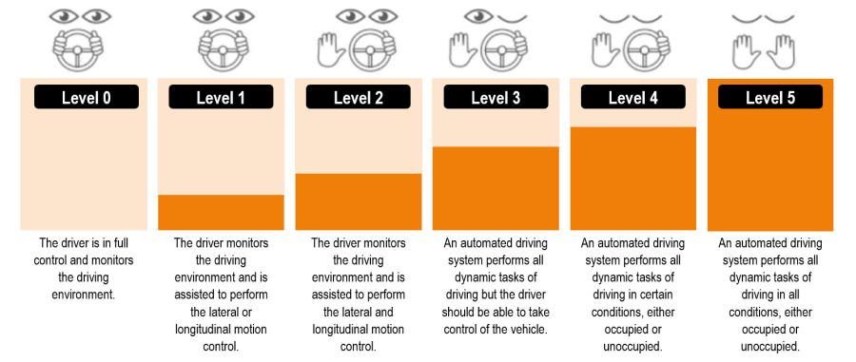The classification of automated vehicles is done with dividing them on the basis of extent of automation. The first classification was given by National Highway Traffic Safety Administration (NHTSA), USA[6] in 2013. But in 2016, SAE presented its classification of six levels of automation which was set as the international standard for all automated vehicles.

LEVEL 0:

NO AUTOMATION Vehicles in which all the controlling operations are in driver’s hands. The piloting, braking, acceleration, deceleration and emergency braking is done solely by the driver. Vehicles with basic warning systems like coolant temperature, oil pressure etc. also fall in this category.

LEVEL 1:

DRIVER ASSISTANCE Some specific control functions that assist the driver in operating are included in level 1 cars. The driver is responsible for all operations but vehicle provides assistance if he utilizes it. Lane Keeping Assistance (LKA) steers the vehicle into a particular lane and Adaptive Cruise Control (ACC) is also an automated system which regulates speed and the driver steers. All the automated[8] systems work independently and still require some input from the driver. Nowadays, this level of automation is seen in most cars like Honda civic, jeep, BMW.

LEVEL 2:

PARTIAL AUTOMATION In partial automation, the vehicle has control of the vehicle in terms of steering, acceleration/deceleration and braking but the driver must monitor the driving and should be ready to take control at any time in case the automated systems are unable to perform[9]. Level 2 automated cars are available in market and include two or more combined automated functions.

LEVEL 3:

CONDITIONAL AUTOMATION In limiting self-driving, the vehicle is in full control and alerts the driver to retake control in situations which require driver assistance. The driver can take his ‘eyes off’ the road and should take control when the system needs it[10]. Vehicles with level 3 automation usually use RADAR technology for sensing their surroundings. Tesla autopilot system, General Motors super cruise technology and Audi A8 have level 3 automation.

LEVEL 4:

HIGH AUTOMATION Vehicles in this level are capable of handling immediate response like emergency braking. Driver attention is not required and need not be in the driver seat. But driver can take control in unusual environment conditions. Google car prototypes fall under this category.

LEVEL 5:

FULL AUTOMATION No human involvement is required. The vehicle will not allow the passenger to take control of the operations. Robotic taxi will fall under this category.

**SENSOR TECHNOLOGIES:-**

Autonomous vehicles are being developed using complex algorithms and neural networks and advance technologies[11]. In this section, technologies used by vehicles to sense their environment have been assessed.

ULTRASONIC SENSORS:

Ultrasonic sound waves are sound waves having frequency greater than 20,000 hertz. Sensors use these sound waves to locate nearby obstacles, the waves hit any object and reflect back thus mapping the surrounding and accordingly give the output back to the system.

* SONAR used in submarines and boats use same concept.
* Bats are able to navigate using a similar technique called echolocation.
* Ultrasonic sensors are useful in automated parking but can be used only at low speeds.

IMAGE SENSORS:

In image sensing, a number of cameras are placed in the vehicle to generate images of the surrounding. Traffic lights and signs are easily interpreted. Image sensors are hard to use in fog, rain or night.

RADAR SENSORS:

Radio Detection and Ranging (RADAR) sensors emit high frequency radio waves which echo after hitting an obstacle and a tuned antenna picks up the signal and informs the system about the object position and speed.

* Radars are widely used in ships and aircrafts.
* Currently, radars are being used in some semiautonomous vehicles like Tesla.
* The reflected signals are hard to trace back in an open field or very packed space.

LIDAR SENSORS:

To overcome the difficulties with radars, Light Detection and Ranging (LIDAR) was developed. Lidar sensors use low intensity and harmless laser beam to scan the environment. The data from the sensors and cameras are processed together in the master software which creates a real time virtual 3D environment. But lidar sensors are much more expensive than radar sensors. Google car and Uber self-driving taxis use lidar sensors.

CODE:-

I started with loading all the required libraries and dependencies.

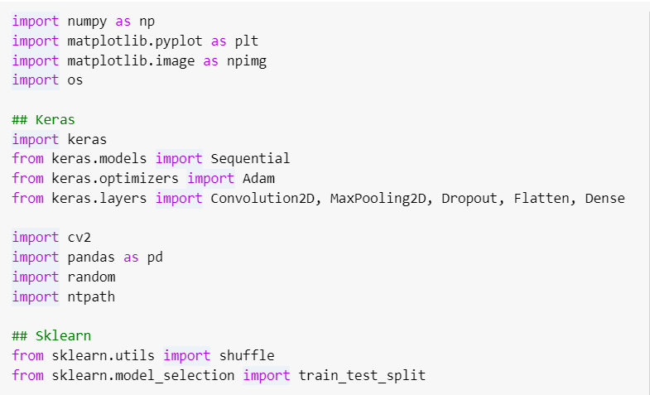

The dataset has 6 columns — center, left, right (camera image paths), steering, throttle, reverse, speed (values). I have used pandas dataframe to display the first five rows in the dataset.

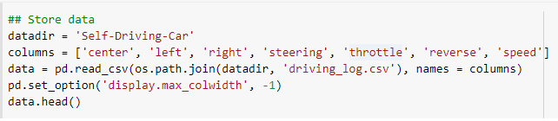

Since the prefix of the left, right and center image paths was the same for all the rows so I decided to remove the prefix part throughout the dataset.

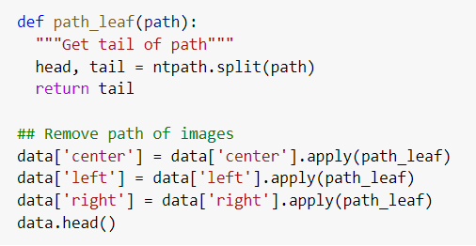

Next, I plotted distribution of the steering wheel angle values. As one can see there is a huge spike near zero which means that most of the times the car is driving straight.

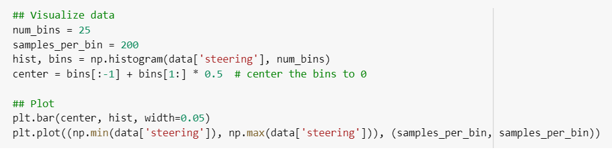

Then I made a function to load all the images as well as the steering wheel angle values in a numpy array.

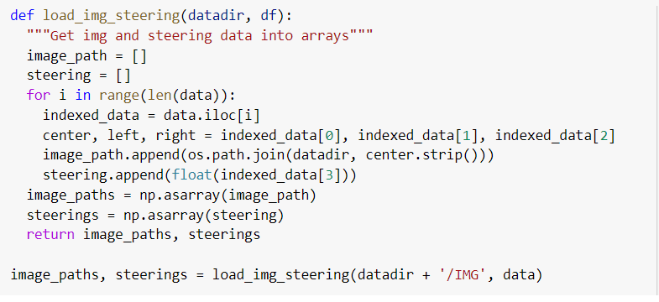

The next step was to split the data using the 80–20 rule which means using 80% of the data for training while the rest for testing the model on unseen images. Also, I plotted the sample training and validation steering angle distributions.

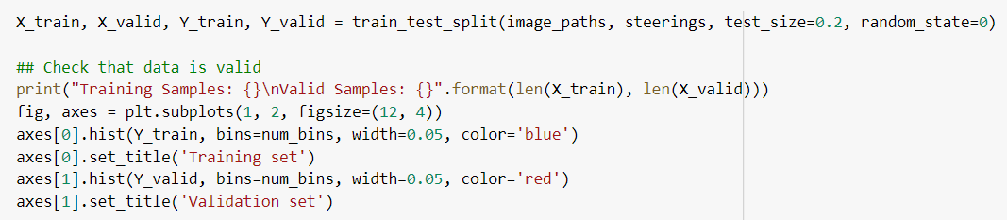I continued by doing some image processing. I cropped the image to remove the unnecessary features, changes the images to YUV format, used gaussian blur, decreased the size for easier processing and normalized the values.

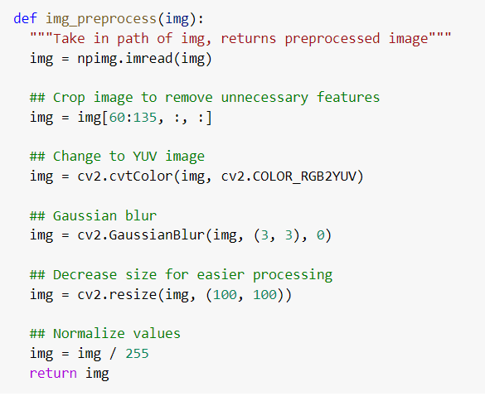

To compare and visualize I plotted the original and the pre-processed image.

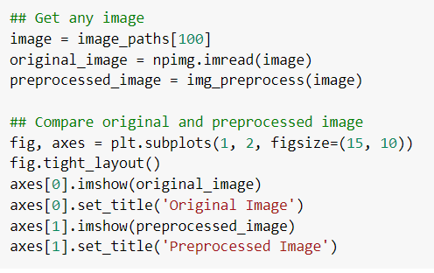

So far so good. Next, I converted all the images into numpy array.

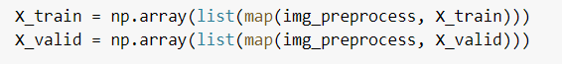

The next step was to build the model. I have used ResNet as the pre-trained weights. I have removed the last 4 layers to make my own custom neural network.

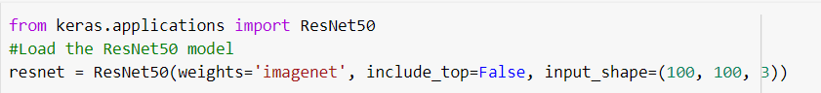

On top of the heavy resnet architecture, I have used the flatten layer to normalize the weights. Next, I have used three dense layers with 100, 50 and 10 neurons respectively and elu as the activation function. Also in between, I have used 50% dropouts to reduce over-fitting the values to the training set.

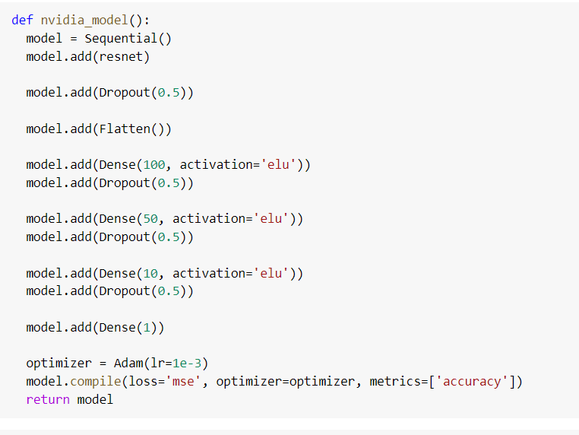Finally, I trained the model for 25 epochs with a batch size of 128. Also, I plotted the training and the validation loss as a function of epochs.



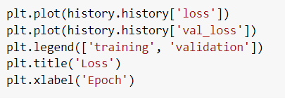

CONCLUSION:-

The automobile industry is ever-evolving with new technologies to increase the handling and efficiency of the car being invented and employed every year. The most anticipated and talked about topic – ‘autonomous vehicles’ will revolutionize the way people travel. With the advent of autonomous vehicles just around the corner, experts are evaluating the advantages/disadvantages and the impacts have been discussed thoroughly but surely the positive impacts of driverless concept are significant and cannot be disregarded. Also, the impacts turning positive or negative hugely depends upon the mindset of humans using it, thus regulations and rules are to be set for better results. The obstacles are a cause of concern but can be improved with time and experience. Therefore, due to some challenges it would not be wise to discard the whole concept. The applications of autonomous vehicles are numerous which would certainly be very helpful for transportation industry as self-driving taxis and delivery trucks would reduce the manual labor a lot. Since Self Driving Car is the major up gradation in automatable industry in future, this project focuses on bring changes in road safety and commuting and significantly reduce accidents and human errors through continuous learning by the system. This project will be a revolution in transporting differently able people and blind people can drive independently. With our product as base mobile applications can be developed where owner summon the vehicle via the app and produce a fully autonomous car on passing the law (Fully autonomous cars are still illegal, but will be the future mode of transport).